
UNIVERSITY OF MANAGEMENT AND TECHNOLOGY
Software Engineering Assignment: 3, CLO: 3
Total Marks: 50 Ayesha Matloob F2024065490

- Construct a Context Diagram showing the system boundary and its interaction with external entities.

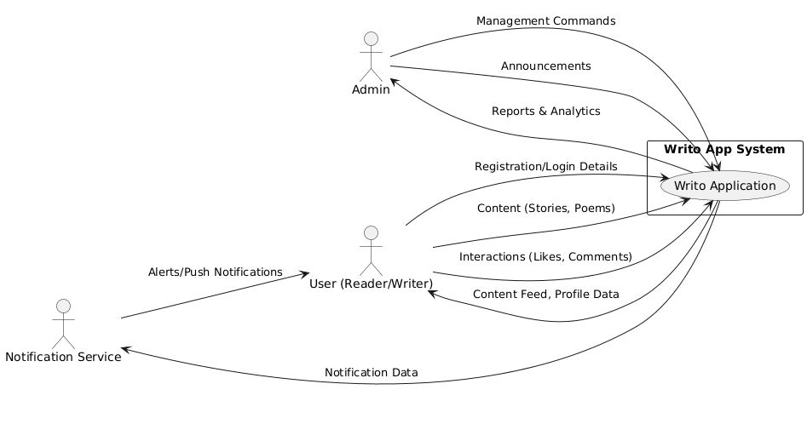
- Convert the Context Diagram into a Data Flow Diagram (DFD) Level 0, identifying the major processes and data flows.

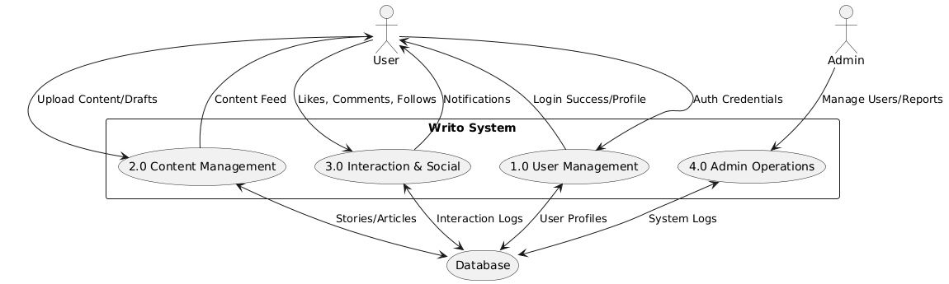

- Draw an Entity Relationship Diagram (ERD) representing the system’s data entities and their relationships.

